**Backup restore tests - customer request:**

If we received any restore requests, we have check on the below points.

* What kind of restore they required, whether it is file level restore or disk restore or entire VM restore.
* Then we have to ask them, which date restore is required.
* On Backups Tab in VM, we can see which dates backups are available, recent days backup will have both Snapshot backup along with Vault Backups, which means, if we restore from any backups which have snapshot, restore will get complete within very few mins, if not it will take longer time as per the size of Disks we are restoring.

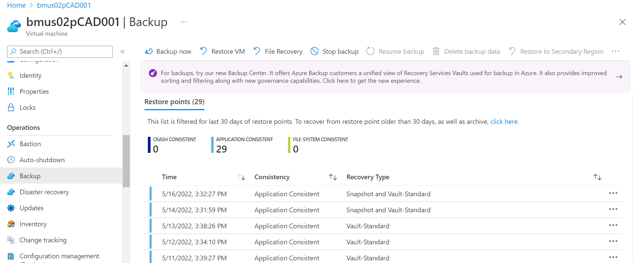

* Select the File Recover or the Restore VM tab as per the customer requirement.

**File Restore:**

* File restore can be performed only if the disk size is less than 4 TB size, if the disk size is larger than 4 TB size, then the disks will not get mounted in server.
* Next Select the restore point as per the requirement, and click on Download executable file.

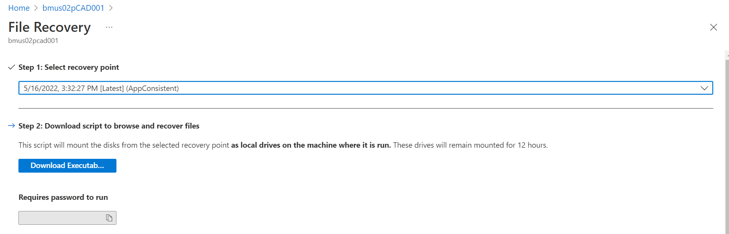

* Once download executable file is selected, password will get generated.

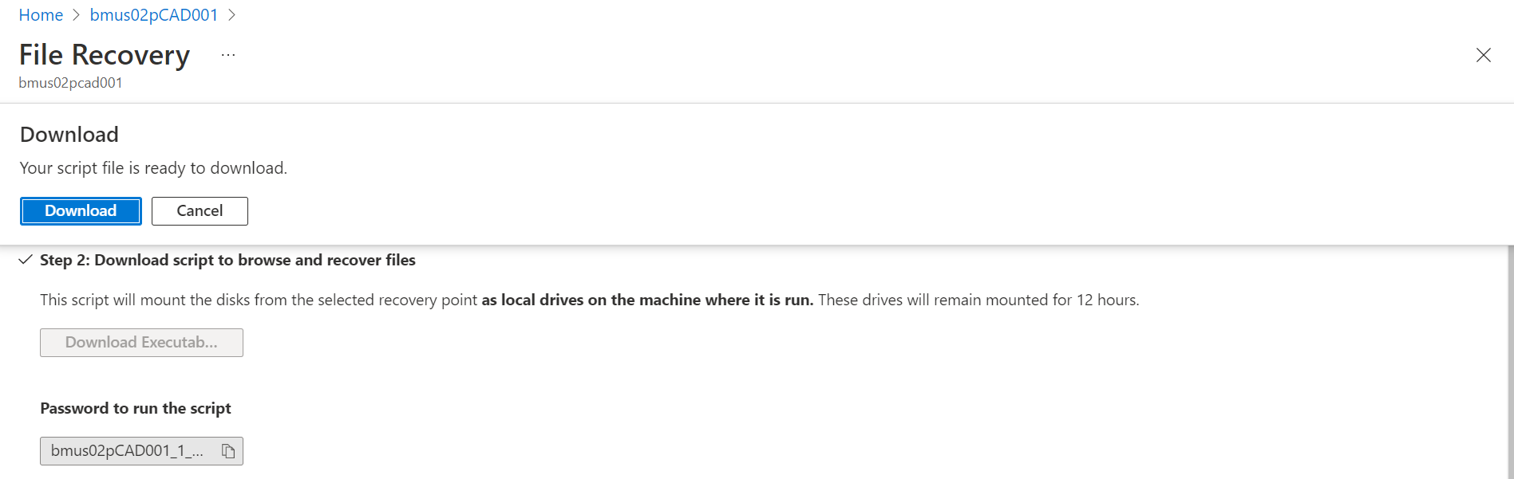

* When we run that executable file, it will ask for the password, once the password is authenticated, the disks will get mounted in the server, with which we can recover the required files.
* Once the activity is completed, we have to unmount the disks.

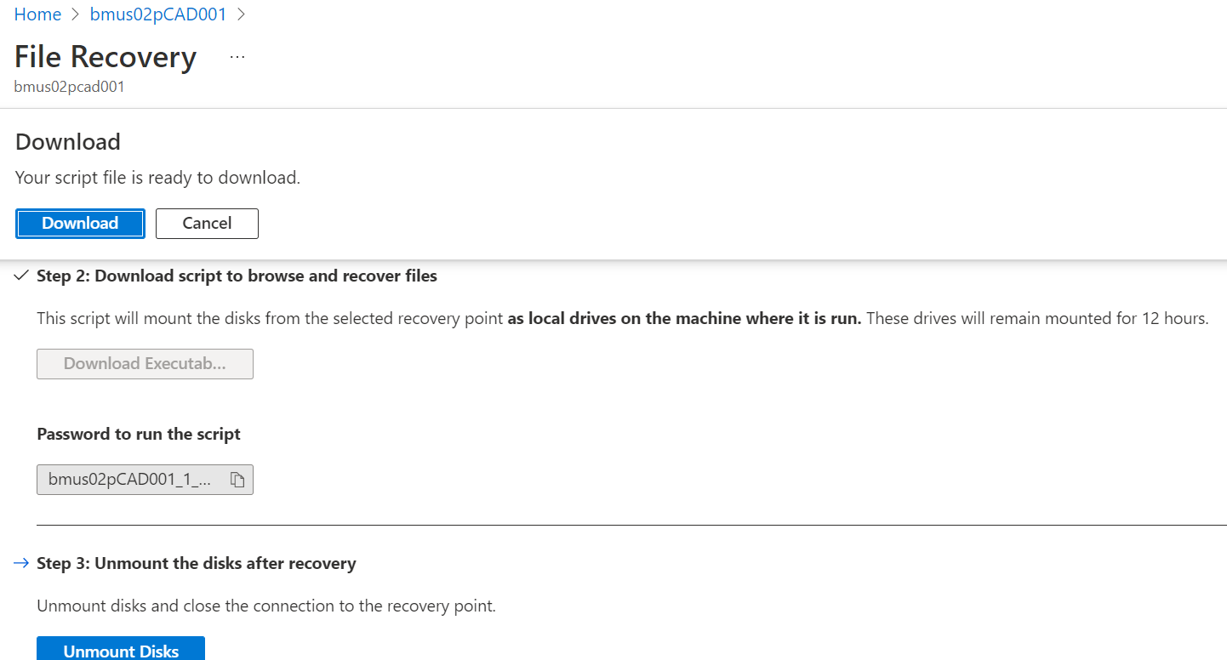

**Disks Recovery or Full VM Restore:**

* For this we have to click on “Restore VM”, and select the restore point, next it will ask create new or replace existing.
* Create new -- is to create new VM from the restore point, here it will ask whether you need to provide the restore type either as “create new VM or restore disks”
* Replace Existing -this is to restore only the Data Disks.

